Plain-language audit for BJJ-2025-0712.R1_NO_ALT.pdf
This file explains the full audit in simpler language.
It is for faculty, librarians, students, and busy readers.
What this file does
It keeps the main audit facts. It removes technical load.

Source audit read: 292 text blocks and 6 tables.

What this audit found
3 things stop people reading parts of this PDF. 11 things make reading harder. 6 things are small problems.
3  things stop people reading parts of this PDF | 11  things make reading harder | 6  things are small problems

Read the six cards below first. Each card gives one problem and one fix path.

1. Some pictures have no description
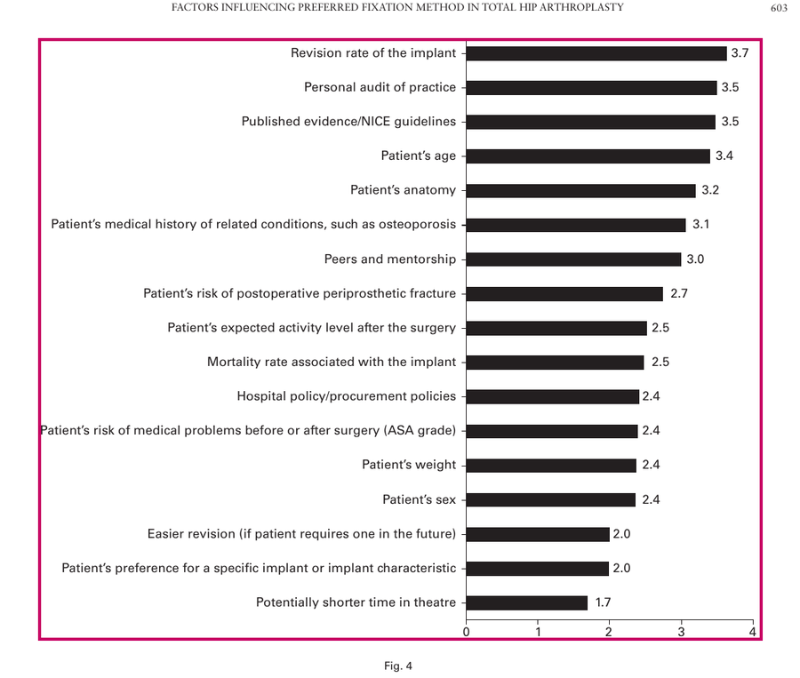
Picture evidence.
Problem
Some pictures are visible on the page. The PDF gives no useful text for them.

Impact on the reader
A blind reader may miss the meaning of the picture.

Fix steps
- Find each Figure tag.
- Add short Alternate Text.
- Say what the picture means.
- Save the PDF.
- Test with a screen reader.

2. Blank text is read aloud
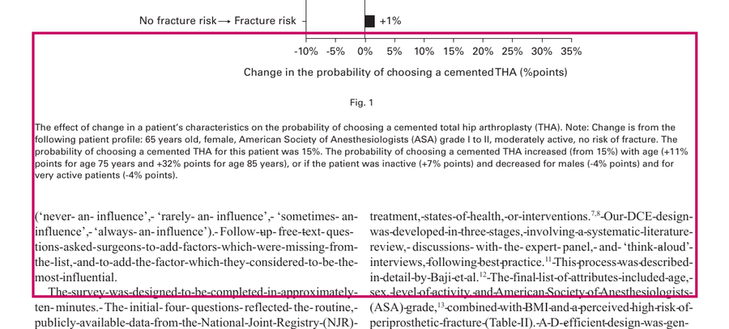
Blank evidence.
Problem
The PDF contains empty marks that can be read as the word blank.

Impact on the reader
The reader may think words are missing.

Fix steps
- Find empty Span tags.
- Remove the word blank.
- Label real answer spaces.
- Mark decoration as Artifact.
- Retest the page.

3. Some content reads in the wrong order
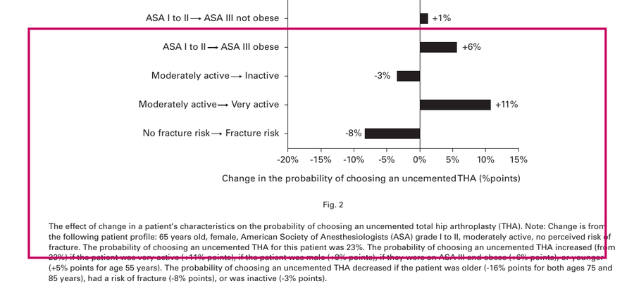
Order evidence.
Problem
The hidden reading order does not match the visible page order.

Impact on the reader
The reader may hear an answer before the question.

Fix steps
- Open the Order panel.
- Compare it with the page.
- Move items into order.
- Check the Tags panel.
- Read the page again.

4. Author names are split apart
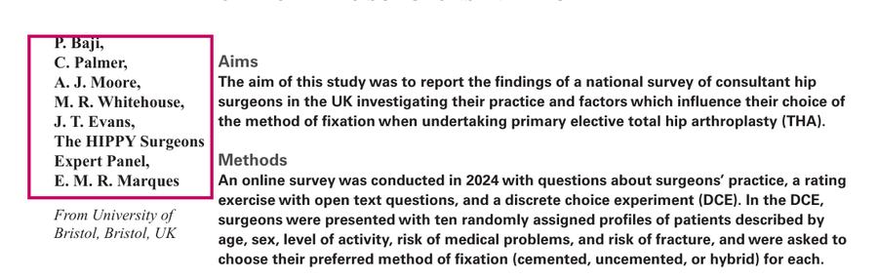
Author evidence.
Problem
The author names look like one group. The PDF tags split them into separate parts.

Impact on the reader
The reader must rebuild the group in memory.

Fix steps
- Find the author block.
- Group the names together.
- Remove empty tags.
- Keep the visible order.
- Test page 1 again.

5. Table headers are not clear
Table evidence
A table needs clear row and column names.

Problem
Some table cells do not say which row or column they belong to.

Impact on the reader
The reader may hear numbers without context.

Fix steps
- Find each data table.
- Mark header cells as TH.
- Set row or column scope.
- Check the table with a screen reader.

6. The text is harder than it needs to be
Text evidence
Short text helps attention, memory, and recovery.

Problem
The audit found high reading level, long sentences, and long paragraphs.

Impact on the reader
Readers may lose focus before they reach the main point.

Fix steps
- Rewrite long sentences.
- Use common words.
- Add clear headings.
- Use bullets for steps.
- Check the reading level.

What you can do next
- Send the full audit to the publisher or remediation team.
- Use this file to explain the main issues to students and staff.
- Ask for a repaired PDF and test it again before assigning it.
Footer note
This is one of four files in the audit bundle. The full audit with technical details is in 01-Professional-Report.docx. The screen-reader perspective is in 02-Screen-reader-walkthrough.html. The cognitive-load perspective is in 03-COGA-walkthrough.html.

